Threat Hunting and MITRE ATT&CK Mapping
Controlled HTTP Request Simulation — T1499.002 Service Exhaustion Flood

Abstract
This report documents a small, controlled HTTP request experiment and maps its observable behavior to the MITRE ATT&CK framework. The selected sub-technique is T1499.002, Service Exhaustion Flood, under the Impact tactic. A Kali Linux virtual machine hosts an Nginx web server, while Splunk Enterprise on a Windows host collects the Nginx access log through a Splunk Universal Forwarder. A limited number of HTTP requests are generated from authorized test clients and then examined in Splunk. The goal is to determine whether the logs reveal request volume, source IPs, and changes over time. This is a detection exercise, not a full denial-of-service test: the limited request volume is not intended to exhaust the server or prove service disruption.

1. Introduction
MITRE ATT&CK is a knowledge base that organizes adversary behavior into tactics, techniques, and sub-techniques. Tactics describe the adversary's goal, while techniques describe how that goal may be achieved. Procedures are concrete examples of how a technique is used in practice. In this lab, the Impact tactic is relevant because denial-of-service activity aims to reduce or prevent access to a service.
The report focuses on a single sub-technique rather than attempting to cover many unrelated attack types. MITRE ATT&CK describes T1499.002 as Service Exhaustion Flood and includes high-volume HTTP requests as an example of behavior that can overwhelm a web service. Reference: https://attack.mitre.org/techniques/T1499/002/.

2. Selected ATT&CK Technique
ATT&CK tactic | Impact
Parent technique | T1499 — Endpoint Denial of Service
Selected sub-technique | T1499.002 — Service Exhaustion Flood
Target service | Nginx HTTP server on Kali Linux
Observed behavior | Repeated HTTP requests from test clients
Log source | Nginx access.log
Detection / analysis | Splunk Enterprise searches and time-based aggregation
Important scope note: the lab emulates and detects a small amount of HTTP request activity associated with the technique. It does not demonstrate a successful service-exhaustion attack, a real DoS, or a distributed denial-of-service event. A DDoS claim would require evidence of distributed attack traffic and service impact, neither of which is assumed in this report.

3. Lab Environment
- Kali Linux virtual machine running Nginx.
- Windows host running Splunk Enterprise at http://localhost:8000.
- Splunk Universal Forwarder on Kali forwarding /var/log/nginx/access.log to the Windows host on TCP port 9997.
- VMware network configured in Bridged mode for the test, so authorized clients on the same network can reach the Kali web server.
- Authorized test clients: the Windows host and, if used, classmates' devices connected to the same lab network.

4. Procedure
- Confirm Nginx is running on Kali and that the web page responds locally.
- Confirm the Splunk receiver is listening on TCP 9997 and the Universal Forwarder is configured to send the Nginx access log to the receiver.
- From an authorized client, open the Nginx page once to verify connectivity.
- Run a short, rate-limited request test against the lab server. Keep the test limited and stop if the service becomes slow or unavailable.
- Confirm that the requests appear in /var/log/nginx/access.log on Kali.
- In Splunk, search the forwarded Nginx access log and compare request counts by source IP and by time interval.
- Save screenshots showing the setup, test request output, raw log entries, and Splunk results.

5. Detection Engineering in Splunk
The following SPL searches are starting points. Adjust the index and source filters to match the actual Splunk environment.

5.1 Requests grouped by client IP
index=* source="/var/log/nginx/access.log"
| rex field=_raw "^(?<client_ip>\S+)"
| stats count as requests by client_ip
| sort - requests
Purpose: identify which client IPs generated the most logged requests in the selected time range. A high count by itself is not proof of an attack; compare it with the baseline and the controlled test window.

5.2 Request activity over time
index=* source="/var/log/nginx/access.log"
| rex field=_raw "^(?<client_ip>\S+)"
| bin _time span=1m
| stats count as requests by _time client_ip
| sort _time
Purpose: show whether request counts increase during the test window and whether the activity comes from one or multiple source IPs. A one-minute interval is useful for a small test; shorter intervals may be more useful for larger datasets.

5.3 Optional focused view for the test window
index=* source="/var/log/nginx/access.log"
| rex field=_raw "^(?<client_ip>\S+)"
| timechart span=10s count by client_ip
Use this view only if the data volume and Splunk configuration support it. A brief test may be too small to create a clear spike.

6. Results and Evidence
Complete this section after running the experiment. Do not enter estimated values: use the actual Splunk results and screenshots. If the search returns no events, document the issue and check the index, source path, forwarding status, and selected time range.
Observation | Actual result | Interpretation
Total requests during test | 365 | Baseline data was not available for a reliable comparison.
Source IPs observed | 6 | The number of unique source IP addresses must be verified in Splunk
Highest requests per source | 125\172.20.10.3 | The highest request count per source must be checked against normal traffic patterns.
Visible increase over time | Yes, ~11:34, ~11:37, ~11:46 | The request rate over time must be reviewed in Splunk to identify any noticeable increase.
Service availability | Normal | The service remained available during the test, and actual service exhaustion was not demonstrated.

- Figure 1. Nginx running and the Kali server IP address.
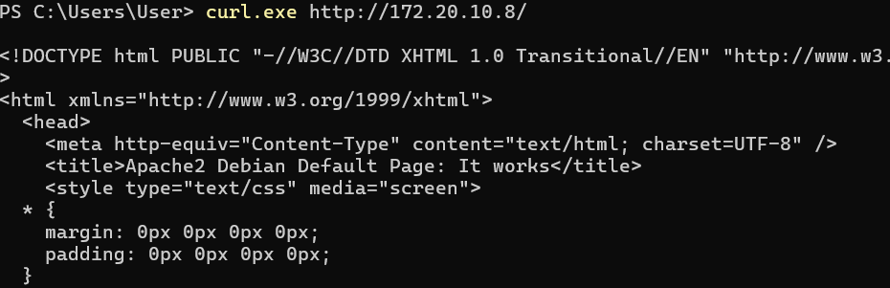
- Figure 2. Splunk receiver / forwarder configuration showing TCP 9997 and the Nginx access-log input.
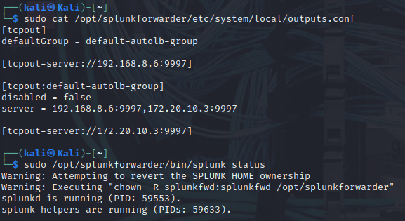
- Figure 3. Controlled test command and its output on the client.
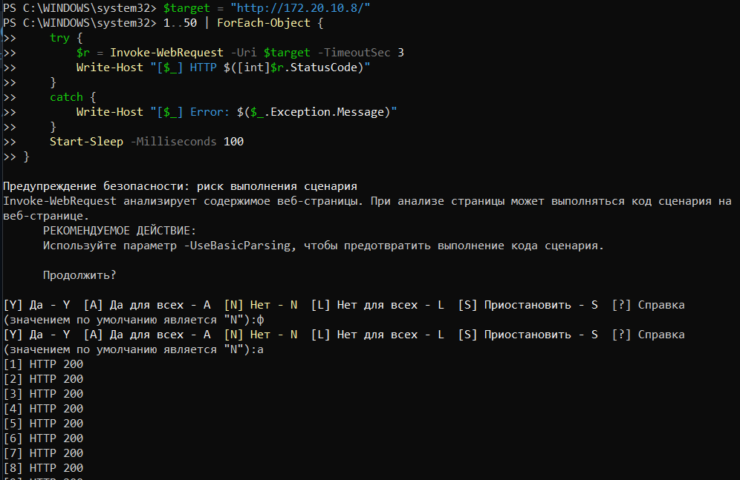
- Figure 4. Corresponding Nginx access.log entries on Kali.
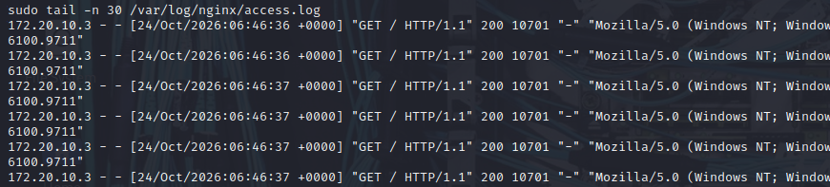
- Figure 5. Splunk search showing request counts by client IP.
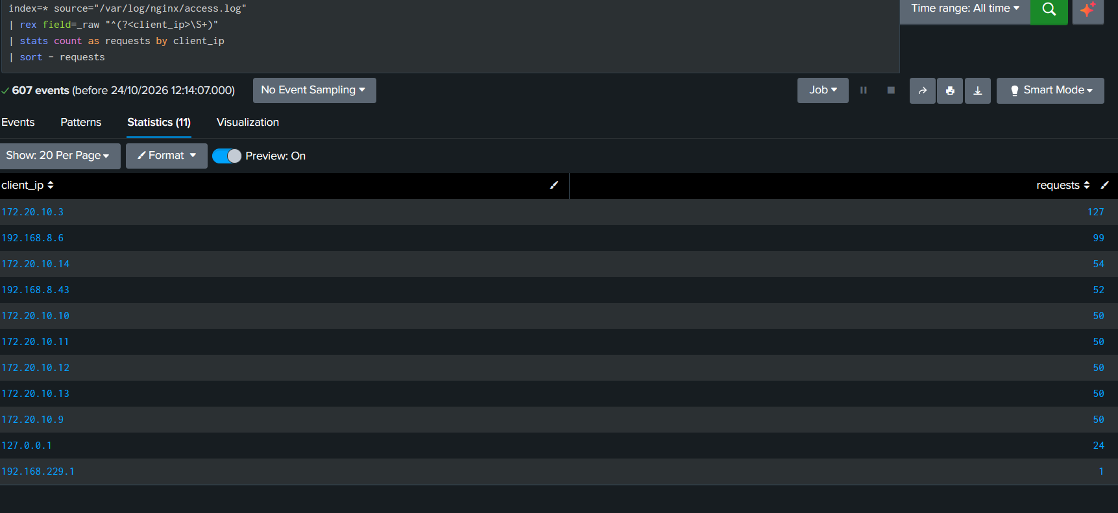
- Figure 6. Splunk time chart showing request activity during the test.
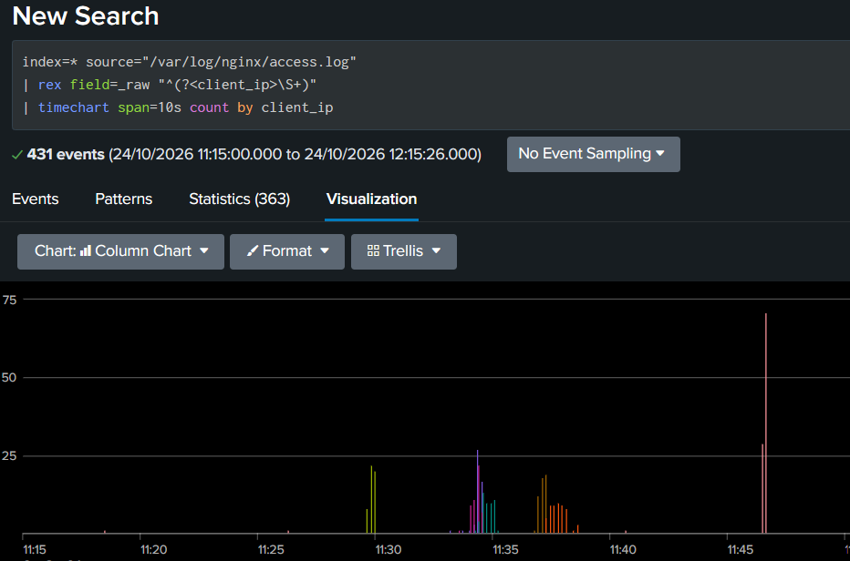
- Figure 7. MITRE ATT&CK Navigator layer with T1499.002 selected and annotated.
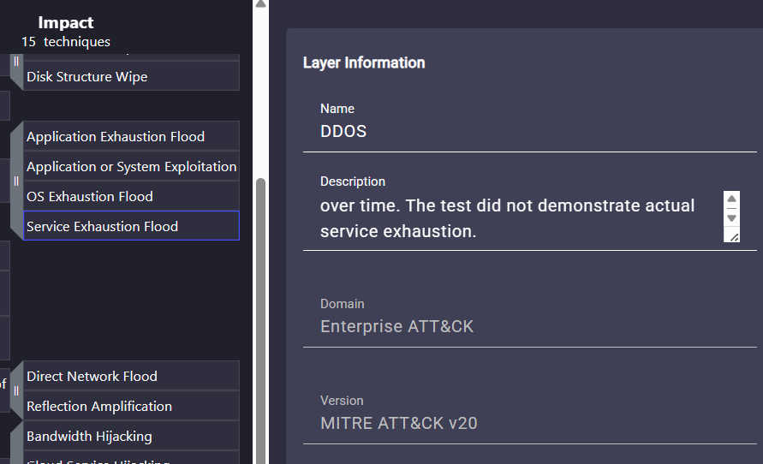

7. ATT&CK Navigator Mapping
Open MITRE ATT&CK Navigator at https://mitre-attack.github.io/attack-navigator/. Create a layer for the Enterprise ATT&CK matrix, find T1499.002 — Service Exhaustion Flood, and select or annotate it. Add a note explaining that the lab generated limited HTTP requests and checked whether Nginx logs and Splunk made the request sources and timing visible. Do not mark the technique as fully validated solely because requests were logged.
ATT&CK element | Lab mapping | Evidence / caveat
Tactic: Impact | Goal being studied: service availability impact | No service impact is presumed
T1499 | Endpoint Denial of Service | Parent technique
T1499.002 | Service Exhaustion Flood | HTTP request pattern is relevant; test is low-volume
Telemetry | Nginx access.log forwarded to Splunk | Shows logged requests, source IP and timestamps
Detection outcome | Request counts and time-based activity | Fill in from actual results

8. Limitations
- The test is intentionally low-volume and does not attempt to exhaust CPU, memory, worker processes, or network capacity.
- Nginx access logs show HTTP requests but do not, by themselves, prove that a service was unavailable or that system resources were exhausted.
- A small number of clients on one local network is not sufficient evidence of a real DDoS attack.
- A detection rule based only on request counts can generate false positives; normal traffic patterns and a baseline should be considered.
- The source IP in a log identifies the address observed by the server, which may be affected by NAT or other network configuration.

9. Conclusion
This lab demonstrates a basic workflow for mapping observed activity to MITRE ATT&CK and investigating web requests in Splunk. The selected behavior is associated with T1499.002, Service Exhaustion Flood, under the Impact tactic. Nginx access logs and Splunk searches can help identify request sources, count requests, and visualize activity over time. The strength of the conclusion depends on the collected evidence: the lab can show that request activity was logged and analyzed, but the limited test should not be described as a successful DoS or DDoS unless service degradation and other supporting evidence were actually measured.

References
- MITRE ATT&CK. Endpoint Denial of Service: Service Exhaustion Flood (T1499.002). https://attack.mitre.org/techniques/T1499/002/
- MITRE ATT&CK. Endpoint Denial of Service (T1499). https://attack.mitre.org/techniques/T1499/
- MITRE ATT&CK Navigator. https://mitre-attack.github.io/attack-navigator/
- Splunk Documentation. Search Reference. https://docs.splunk.com/Documentation/Splunk/latest/SearchReference/
- Nginx Documentation. Logging to syslog / access log documentation. https://nginx.org/en/docs/http/ngx_http_log_module.html

